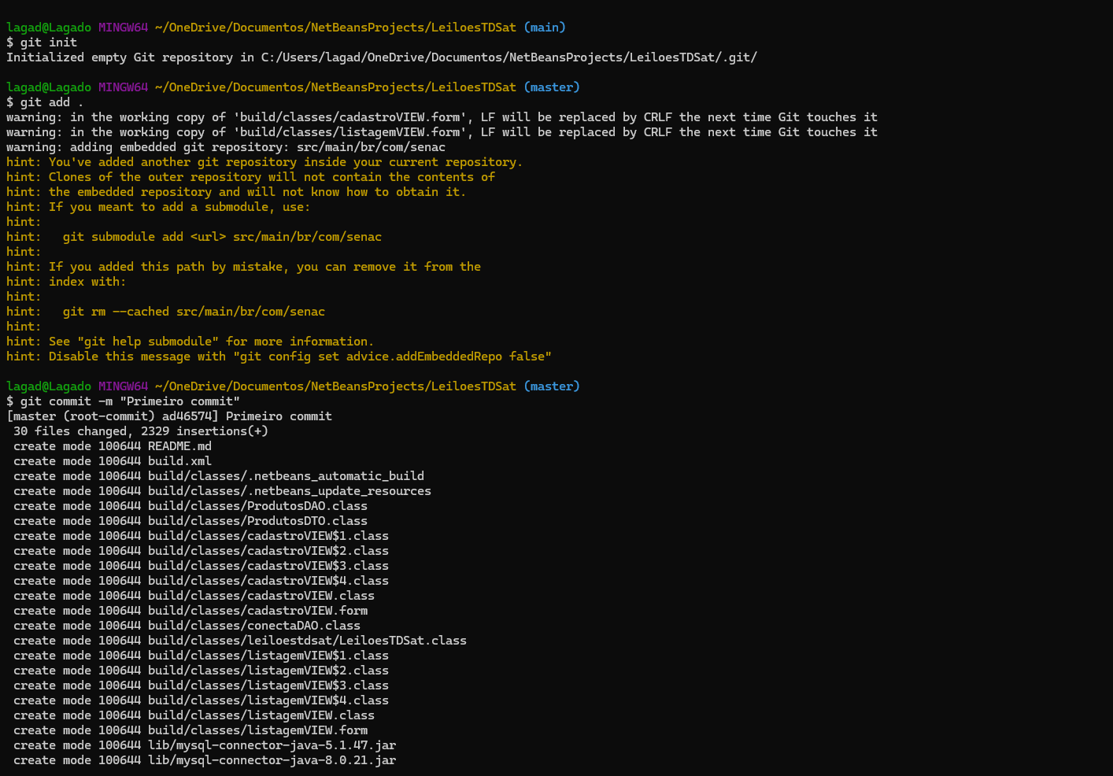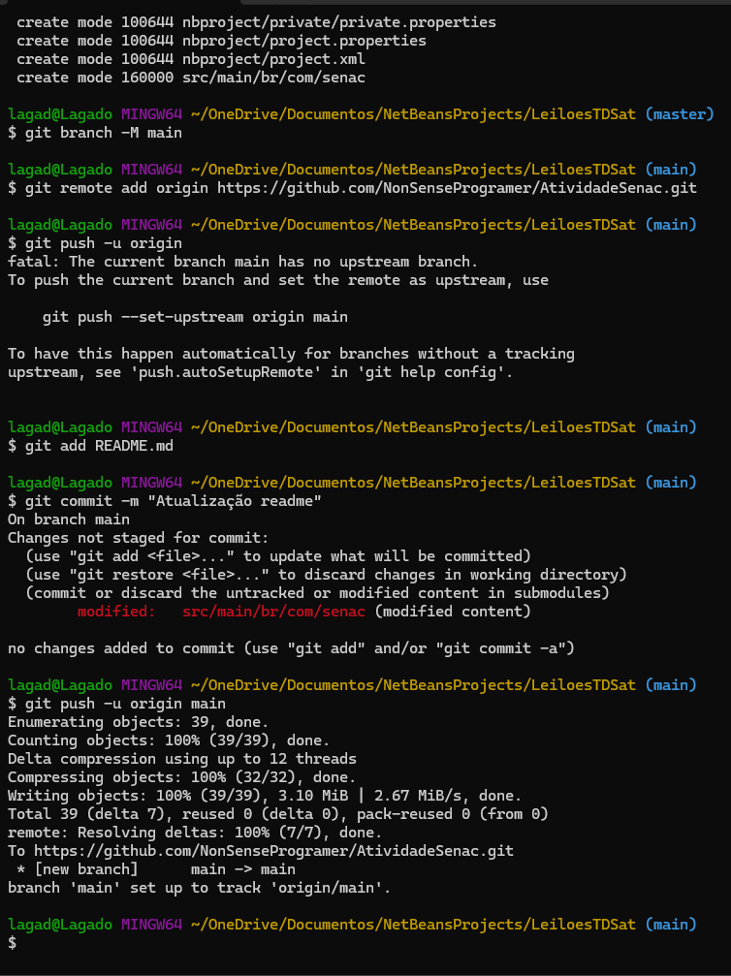

Git Link: https://github.com/NonSenseProgramer/AtividadeSenac.git

